# Introduction

In this guided practice you will view and change the operations master

# Requirements

* Guided practice - Installing Active Directory is complete.
* Guided practice - Creating a Child Domain is complete.
* Guided practice - Creating a New Domain Tree is complete.

# Tasks

## View the Domain wide operations master roles from the GUI

1. **Logon** to the **CIS256-DC2** virtual machine using the **absadmin** account.
2. View Domain wide operations masters
   1. Open **AD Users and Computers.**
   2. Right-click the **domain** and select **Operations Masters.**
   3. Identify the operations master roles shown and which domain controller owns these roles.

|  |  |
| --- | --- |
| Role | Owner |
|  |  |
|  |  |
|  |  |

## View the Domain wide operations master roles from the command line

1. Open an **administrative PowerShell** prompt.
2. Use the **Get-ADDomain** command to **view** the **roles.**

## View the Forest wide operations master roles from the GUI

### View the Domain Naming Master

1. View Forest wide operations masters.
   1. Open **AD** **Domains** **and** **Trusts**.
   2. Right-click the **top node** and **select** **Operations Masters**.
   3. Identify the operations master roles shown and **which domain controller owns** these roles.

|  |  |
| --- | --- |
| Role | Owner |
|  |  |
|  |  |
|  |  |

### View the Schema Master

1. **Install** the **Schema Management Snap-In** as follows:
   1. Open an administrator shell
   2. Type🡪 **regsvr32 schmmgmt.dll**
2. Access the Schema Management snap-in
   1. Open an **MMC** console
   2. Add the **Active Directory** **Schema** snap-in, right-click the **top node** and select **Operations Master.**
   3. Identify the operations master **roles** shown and **which domain controller owns** these **roles.**

|  |  |
| --- | --- |
| Role | Owner |
|  |  |
|  |  |
|  |  |

### View the Forest wide operations master roles from the command line

1. Open a **PowerShell(Admin)** prompt.
2. Use the **Get-ADForest** command to **view** the **roles.**

## Transfer the Domain Naming Master role to another domain controller using the GUI

1. Login to the **CIS256-DC1** virtual machine using the **absadmin** account.
2. Open **AD** **Domains** and **Trusts.**
3. Connect to the **CIS256-DC3** (**LTDC**) as follows:
   1. Right-click the **Active Directory Domains and Trusts** node.
   2. Select **Change Active Directory Domain Controller**
   3. On the **Change Directory Server** dialog box perform the following:
      1. Selectthe **This Domain Controller of AD LDS instance** radio button.
      2. In the **Look in this domain:** textboxtype or select **lametech.com.**
      3. In the **Type a Directory Server… textbox** type **LTDC** and then click **OK.**
4. Right-click the **Active Directory Domains and Trusts** node.
5. Select **Operations Master** from the context menu you should see **absdc1.abscorp.com** in the **top** box and **ltdc.lametech.com** in the **lower** box.
6. Transfer the role **by** **clicking** the **Change** **button.**
7. You will see a prompt that asks if you are sure. Click the **Yes** button.
8. Use the command line to verify that the role was transferred.

## Transfer the Schema Master role to another domain controller using PowerShell

1. Login to the **CIS256-DC2** virtual machine using the **absadmin** account.
2. Open a **PowerShell (Admin)** prompt.
3. Type **get-help Move-ADDirectoryServerOperationMasterRole -examples** to view examples of moving roles.
4. Use PowerShell help to determine the command to transfer the **Schema Master** role to your server.
5. Transfer the **Schema Master role** to the **Charlotte DC** (**CHDC**).

**Note:** **absadmin** does not have permissions to transfer this role; you will need to use the **-credential** option to run this command as the **abscorp\administrator.** The user must be a member of **Schema Admins** to move the **Schema Master** role.

## Transfer the PDC Emulator role to another domain controller using PowerShell

1. Open an **Powershell** **(Admin)** prompt
2. Type **get-help Move-ADDirectoryServerOperationMasterRole -examples** to view examples of moving roles.
3. Use the help to determine the command to transfer the **Infrastructure Master** and **PDC Emulator** roles to your alternate domain controller.

**Note**: You will not be moving the PDC emulator, only identifying the correct command.

1. List the command you would use here.

## Submission Requirements

1. **Download** the **grading** **script** from the assignment page to the **C:\Scripts** folder.
2. Check your lab by running the following command:

Invoke-Pester -Path C:\Scripts\GP07-Viewing_and_Transferring_ Operations_Master_Roles.Test.ps1

**Note**: You will see a security warning when running the script. Enter **R** to run the script.

If you want to see more detail, add **-Output Detailed** to the command. This may assist you with troubleshooting

Invoke-Pester -Path C:\Scripts\GP07-Viewing_and_Transferring_ Operations_Master_Roles.Test.ps1 -Output Detailed

1. You should not see any red in the output. Red in the PowerShell way of telling you that an error condition exists. Most of the time, the output will tell you what is wrong. If it is not obvious, contact your teacher and ask for assistance. You will be learning PowerShell during this term. **Correct** any **errors** you may have and run the script until all the output has no red. You should see the output like the images below.

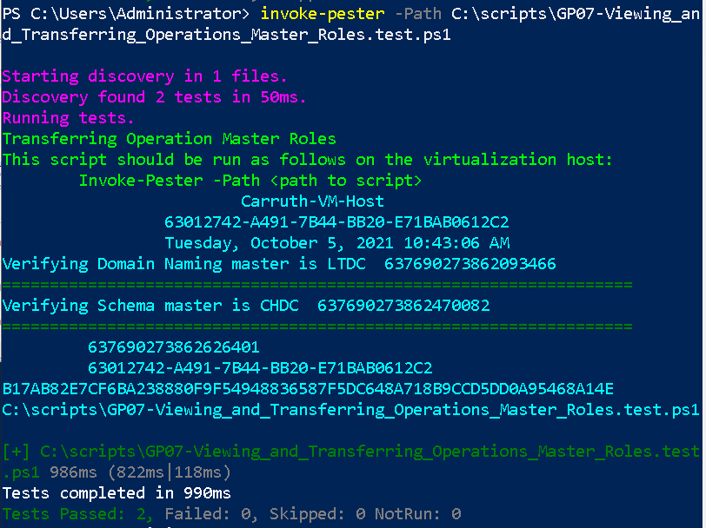

1. Copy and paste the filled in tables, questions, and answers from the steps above into the **new** **Word** **document.**
2. Capture a snippet that shows the PowerShell Command and all its output. If you must use more than one snippet to capture the output, you must have at least **one line of overlap** in the snippets. The text in the snippets **must be legible** when pasted into the Word document. Paste the snippet(s) into the **Word** **document.**
3. **Upload** the **document** in the submission area for the assignment.